I: A LITTLE HISTORY

The battle of the Somme is one of the most important battles that were fought in the Great War. It lasted from July 1st till November 18th 1916 and opposed considerable numbers of soldiers, many of whom unfortunately were to lose their lives. However, in French collective memory, the battle of the Somme is often eclipsed by the battle of Verdun. It is not so in British collective memory.

WHY THE SOMME?

In December 1915 in Chantilly, the Allies had decided to launch in 1916 a series of simultaneous great offensives on three fronts: the French, the Russian and the Italian ones. As far as the French front was concerned, it had been agreed that the offensive would be launched both by the French and the British armies. This is why the Somme area was chosen because it was the place where the fronts held by both armies were in contact. The French army was to provide the greater number of soldiers (39 divisions out of 70), the British soldiers were to back them up. The offensive was to take place on July 1st.

But on February 21st 1916 the Germans launched the Verdun offensive. This unforeseen event led the Allies to change their plans in the Somme area. Some of the French troops that were to have fought in the Somme had to be sent to Verdun, which means that the battle of the Somme would be thought by a majority of British troops (26 divisions out of 40), contrarily to what had been anticipated, and on a narrower front (40km instead of 70).

THE BATTLE OF THE SOMME: THE SEQUENCE OF EVENTS

It started on July 1st, 1916 at 7.30 AM. It has been preceded by a seven day artillery bombardment (1 732 873 shots had been fired since June 24th by British artillery only…).But this massive destruction was misleading in so far as it made the Allied staff believe the enemy defences had been destroyed and that the ground would be there for the taking.
It wasn’t so… As they attacked, in open country, their adversaries who had been protected by underground shelters, they suffered terrible losses. At the end of the day, the number of British soldiers who had been killed, who were missing, wounded or taken prisoners rose up to 57 400, among whom 19 240 had been killed, i.e. about 18% of the troops launched in the attack. Never ever was there a more deadly day in the history of the British army.

Should the offensive be put an end to? The question was raised but the Germans could then have transferred some troops into the Verdun area. So the offensive went on, often hampered by the bad weather which was slowly transforming the battlefield into a bog. It would be tedious to give a detailed description of all the attacks and counterattacks which took place in the following months. What can be remembered is that at the end of July and in August the battle breaks up; only local, unprofitable actions take place. In September, the Allies take the offensive again but from October onwards, the battle run out of steam with the arrival of the wintry season. All activity stops on November 18th.

CONCLUSION

As in many other Great War battles, the territorial gains were very modest. In five months, the Allies moved only twelve kilometers forward north of the Somme, eight kilometers forward south of it (i.e. a three or two hours walk for a hiker…). They reached neither Bapaume nor Peronne.

However the battle of the Somme acted as a relief for the Verdun front. On several occasions the Germans withdrew some troops from Verdun and transferred them to the Somme.
It also, for the first time, enabled people to visualize what a war in the future would be like. On September 15, the British army used on the front a small number of tanks. Although the result then was not very convincing, it was a decision that proved most important in the future, as later conflicts revealed.

But these paltry gains were obtained after appalling losses: 1 059 543 victims in all, dead, injured or missing. This number represent 419 654 British, 202 657 French and 437 222 German soldiers. Let’s think of them today…
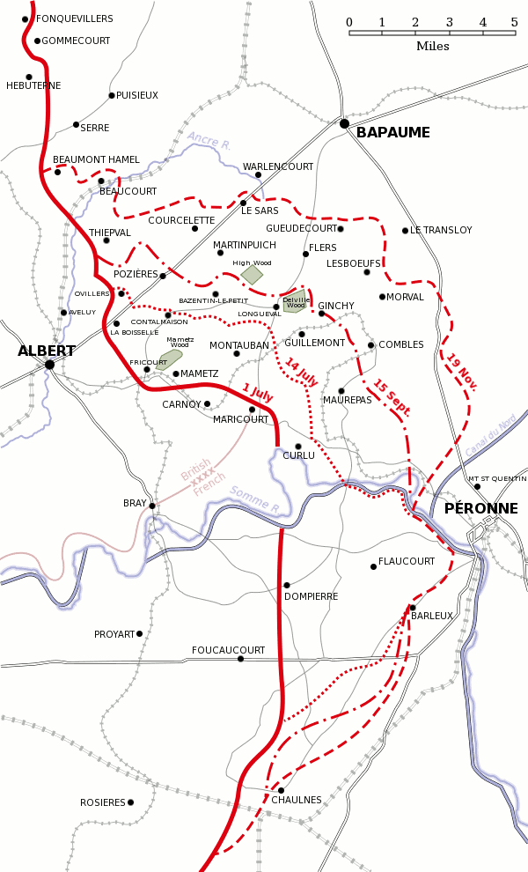

Evolution of the battle, July 1st – November 18th 1916

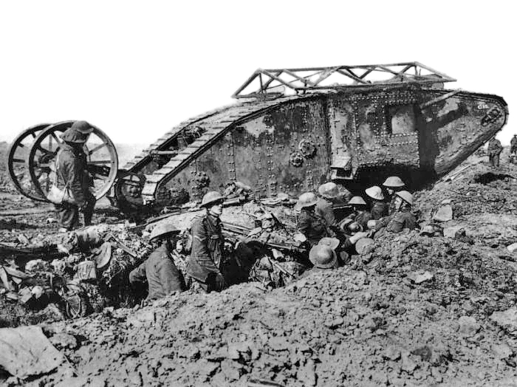

British tank Mk I near Thiepval, September 25th, 1916

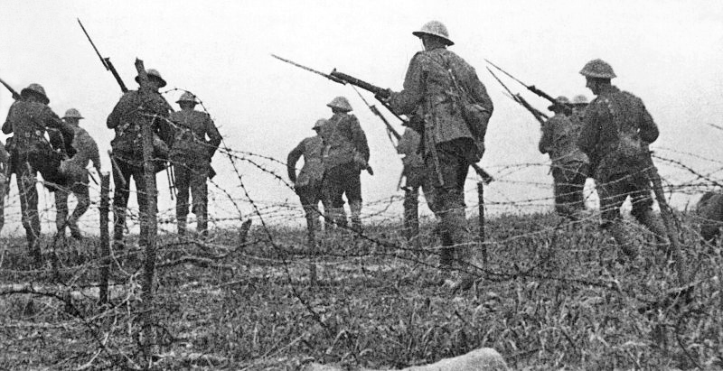

A picture of the film « The battle of the Somme » (1916) which included some pictures filmed during the first day of the battle. It is one of the first known examples of propaganda films.

II : ITINERARY OF THE VISIT

BEAUMONT HAMEL

The Beaumont Hamel memorial commemorates the participation in the battle of the Royal regiment of Newfoundland which suffered very heavy losses in this place as it came into action on July 1st, 1916 (700 men lost their lives in 30 minutes , 801 had lost them by the end of the day, i.e. 92% of the initial number!). The memorial was inaugurated in 1925 and covers 30 hectares of land, including among other features, a network of trenches perfectly preserved.

At the entrance can be seen the memorial to the 29th Division, to which the regiment belonged. But the most interesting feature is to be seen at the top of the rise: a viewpoint indicator and the statue of a caribou, a typically Canadian animal also the emblem of the regiment.

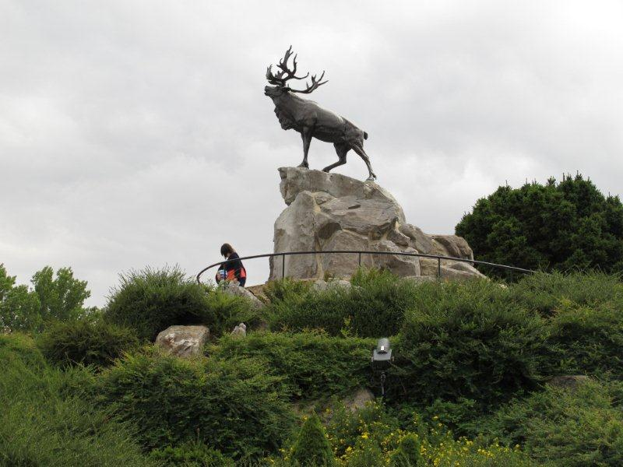

On various plaques are inscribed the names of 820 inhabitants of Newfoundland reported missing during the war.
You can also see the « Danger Tree », the only tree that has survived since that time in the no man’s land.

THIEPVAL

In Thiepval can be seen the most imposing British military memorial in the world (45 meters high). The work of the architect Sir Edwin Lutyens, it was inaugurated in 1932. It is designed to commemorate the British and South African soldiers reported missing in the Somme between July 1915 and March 1918 and whose corpses have never been found. They may also have been found but not identified. There are 73 367 of them; about 90% were killed during the battle of the Somme itself. The names of six soldiers originating in Edenbridge can be found in the lists!

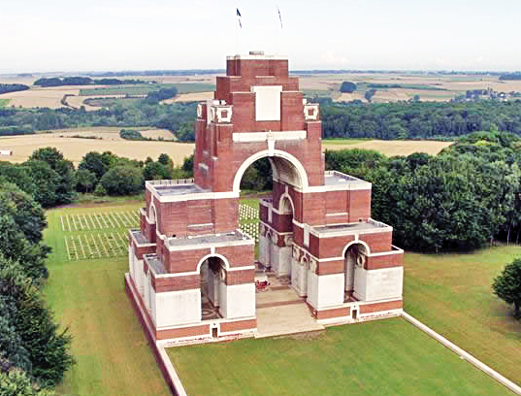

In front of the memorial lies a cemetery with the graves of 300 French soldiers (253 unknown) and the graves of 300 Commonwealth soldiers (239 unknown). In this cemetery one can notice the Cross of Sacrifice with the bronze sword affixed on its vertical branch, point down, as a sign of mourning. The Souvenir Stone bears the inscription: “their names will live forever”, a quotation from the Ecclesiastes in the Bible

In Thiepval can also be found a Visitor’s Centre where you will be welcome. It was inaugurated in 2004 and is managed by the Peronne Historial. Inside can be seen an exhibition. A film is also shown and visitors can have access to a database allowing them to try to find some information about a particular soldier or to find a cemetery or a memorial.

Some time in 2016, probably in June, a new museum is to be opened on the site. Visitors will be able to admire an impressive fresco, the work of the artist Joe Sacco, showing with an incredible precision and innumerable details the first day of the battle.

Near Thiepval can also be seen the Ulster Tower, built in 1921 as a memorial for the 36th division, the one that had penetrated the farthest into the German lines on July 1st and to other units of the same origin that had fought in the war. It is the copy of a tower situated in Ulster, in Clandeboye, where the division used to train.

LA BOISSELLE

As the offensive was launched on July 1st, the British army exploded several very powerful mines so as to breach the first German line. One of the craters created by the explosions (27 tons of explosives in this case), the Lochnagar crater, has been preserved in La Boisselle. It is the only one of its kind to be open to the public, although visitors are not allowed to get into the crater itself. It is 91 meters in diameter and 21 meter deep. The site was purchased in 1978 by a British citizen, Richard Dunning. He then created an association which is responsible for its preservation.

PERONNE

The Great War Historial was opened in 1992. It is currently being reconfigured on the occasion of the centenary of the Great War. The work will be completed in four different phases, between 2014 and 2018.

The conception of the museum is quite original. It is meant to be neither a memorial nor a military museum, but it aims at showing to what extent the Great War altered the lives of both soldiers and civilians, from the cultural and social points of view and not only from a purely military one. This applies to the three countries that took place in the battle, i.e. France, United Kingdom and Germany. The war is seen there from a “cultural history” angle and the three viewpoints are compared.

In order to achieve this aim, the Historial resorted to a special museography: it combined two levels, one situated a little below the ground floor, evoking the trenches, and the ground floor itself where showcases recall the lives of civilians.

There are four rooms altogether, dealing respectively with the pre-war period, the 1914-1916 period, the 1917-1918 period, and the post-war period. There is also a central room where visitors can see an exhibition of various works by the German artist Otto Dix, entitled “Der Krieg” (= The War). They are all inspired by his own experience of the front life at the time and they all dwell on the horror and stupidity of war.

Combined with the Historial is an international research center on the Great War which organizes international symposiums, allocates research grants, publishes books and organizes conferences.

